A Comprehensive Benchmark of ADMET Predictors
in the Era of Foundation Models
Donghai Zhao^{1,2#}, Yuchen Zhu^{1#}, Zhenxing Wu¹, Yue Wan³, Xiaonan Liu¹, Shuaiyan Li¹, Hongxia Xu^{1*}, Tingjun Hou^{1,4*}, Chang-Yu Hsieh^{1,4*}
¹ College of Pharmaceutical Sciences, Zhejiang University, Hangzhou, 310058, Zhejiang, China
² CarbonSilicon AI Technology Co., Ltd, Hangzhou 310018, Zhejiang, China
³ University of Pittsburgh, Department of Computer Science, Pittsburgh, PA 15260, USA
⁴ Zhejiang Provincial Key Laboratory for Intelligent Drug Discovery and Development, Jinhua, 321016, Zhejiang, China

*Corresponding authors:
Chang-Yu Hsieh
E-mail: kimhsieh@zju.edu.cn
Tingjun Hou
E-mail: tingjunhou@zju.edu.cn
Hongxia Xu
E-mail: Einstein@zju.edu.cn

Abstract
Artificial intelligence promises to revolutionize drug discovery, yet the proliferation of ADMET (absorption, distribution, metabolism, excretion, and toxicity) prediction models has obscured genuine progress. We conducted a comprehensive benchmark of over 70,000 models, tackling real-world challenges like limited data, diverse chemical structures, class imbalance, and activity cliffs. Our findings reveal unique advantages by advanced deep learning paradigms, such as (1) large-scale pre-trained graph neural networks like KPGT excel in the beyond-Rule-of-Five (bRo5) chemical space, and (2) the tabular foundation model TabPFNv2 exhibits impressive performance in low-data scenarios. Traditional techniques also remain relevant; for example, ensembling of undersampled models effectively enhance prediction accuracy when facing class imbalance. However, all benchmarked models struggle to predict activity cliffs—where minor structural changes cause dramatic activity shifts—validating a persistent challenge. We also provide a new perspective that the roughness index of molecular property landscape is an insightful metric to assess the representation quality of pre-trained molecular deep-learning models. This study provides a strategic guide for practitioners and a roadmap for future research, emphasizing solutions to tough challenges like structure-activity discontinuities and how to effectively combine advantages of various modeling techniques. These insights advance ADMET modeling and inform AI applications in chemistry, biology, and materials science, particularly in addressing fundamental challenges like low-data learning, out-of-distribution robustness, and structure-activity discontinuities.

- Introduction
In drug research, the absorption, distribution, metabolism, excretion, and toxicity (ADMET) properties of candidates are critical determinants of clinical success¹. Despite substantial annual investments^{2,3}, the success rate of new drug development remains low⁴, with up to 50% of clinical trial failures attributed to poor ADMET profiles¹. As a result, there is an urgent need for more reliable, scalable, and mechanistically grounded evaluation protocols⁵. In recent years, machine learning has emerged as a key enabler in this space ^{6,7}, evolving from classic algorithms^{8,9} using expert-designed features to end-to-end deep learning architectures like Graph Neural Networks^{10,11} (GNNs), which learn directly from molecular structures.
The field has since progressed into the era of molecular foundation models, where large-scale pretraining yields deep representations capable of generalizing across endpoints and molecular classess¹²⁻¹⁶. Pretrained GNNs such as KPGT¹⁷ , MOLMCL ¹⁸, and Uni-Mol¹⁹ have reported strong performance on widely used benchmarks^{20,21}. At the same time, advanced tabular models—most notably AutoGluon²² and TabPFNv2 ²³—have demonstrated competitive or superior performance in structured data domains, and present an underexplored but promising avenue for molecular property prediction.
However, despite this rapid progress, the performance of modern models remains poorly characterized under the core challenges of real-world ADMET prediction. These include: (i) data scarcity and out-of-distribution (OOD) generalization ^{24,25}; (ii) pervasive class imbalance ²⁶; (iii) activity cliffs, where small structural perturbations yield ≥100-fold changes in biological activity, violating smoothness assumptions in standard learning algorithms^{27,28}; and (iv) the increasing shift toward beyond Rule-of-Five (bRo5) molecules, such as macrocycles and peptide-like compounds^{29,30}, which exhibit conformational heterogeneity and fall outside the domain of traditional descriptors.
While a number of valuable ADMET benchmarks exist ^{27,31-35}, most have not evaluated foundation models under a unified framework that simultaneously incorporates OOD shifts, activity cliffs, and the bRo5 chemical space. Furthermore, prior studies often freeze pretrained embeddings without task-specific fine-tuning and evaluate only a narrow set of endpoints or architectures. In addition, models like TabPFNv2, which adapt techniques from the large language modeling to structured tabular inputs, have not yet been systematically evaluated in molecular science.
To address these gaps, we present a unified benchmark for evaluating ADMET prediction under real-world constraints. We curate 10 diverse ADMET datasets reflecting issues like data scarcity and imbalance, and include specialized evaluations targeting activity cliffs and bRo5 molecules. We train and evaluate over 70,000 models across deep learning, tabular, ensemble, and pretrained paradigms. Our results yield robust, generalizable insights into current model strengths and limitations. Furthermore, we introduce the roughness index of molecular property landscapes as a representation-level diagnostic for pretrained models, enabling efficient pre-evaluation of learned embeddings ³⁶. The overall framework is shown in Figure 1.
Given these challenges, several critical questions remain unresolved: How do existing models perform under realistic conditions such as low-data regimes, class imbalance, and scaffold-based OOD splits? Are foundation models pretrained on large unlabeled molecule corpora effective for ADMET endpoints, and how do they compare to tabular models using expert-crafted features? For instance, TabPFNv2 (which incorporates large-language-model inspired technology) have provided new modeling approach that have not yet been thoroughly benchmarked for ADMET predictions. To date, prior studies have often evaluated pre-trained molecular encoders in limited contexts—frequently freezing embeddings without task-specific fine-tuning—and have rarely assessed performance on datasets involving bRo5 compounds or activity cliffs in a unified testing condition. In addition, benchmark efforts remain fragmented, often restricted to specific model types, endpoints, or generalization regimes. A unified, rigorous framework is needed to systematically assess these questions across model classes and task types.
To address these unresolved questions, we present a comprehensive and systematic benchmark to assess how today's leading modeling approaches perform under these demanding conditions. We curated a challenging suite of ADMET datasets reflecting issues like small sample sizes and class imbalance, and incorporated specialized benchmarks for activity cliffs and bRo5 generalization. By training and evaluating over 70,135 models, we provide statistically robust conclusions that offer critical guidance for ADMET modeling and uncover deep insights into the current strengths and fundamental limitations of AI in molecular science. We further propose that the roughness index of different molecular property landscape can provide an alternative yet highly intuitive assessment on the quality of large-scale representation learning by these heavily pre-trained models³⁶. The overall framework of this study is summarized in Figure 1.
Beyond their implications for ADMET prediction, these findings offer methodological insights applicable across scientific machine learning domains—including chemistry, biology, and materials science—where similar challenges of data scarcity, structural heterogeneity, and representation robustness are prevalent.

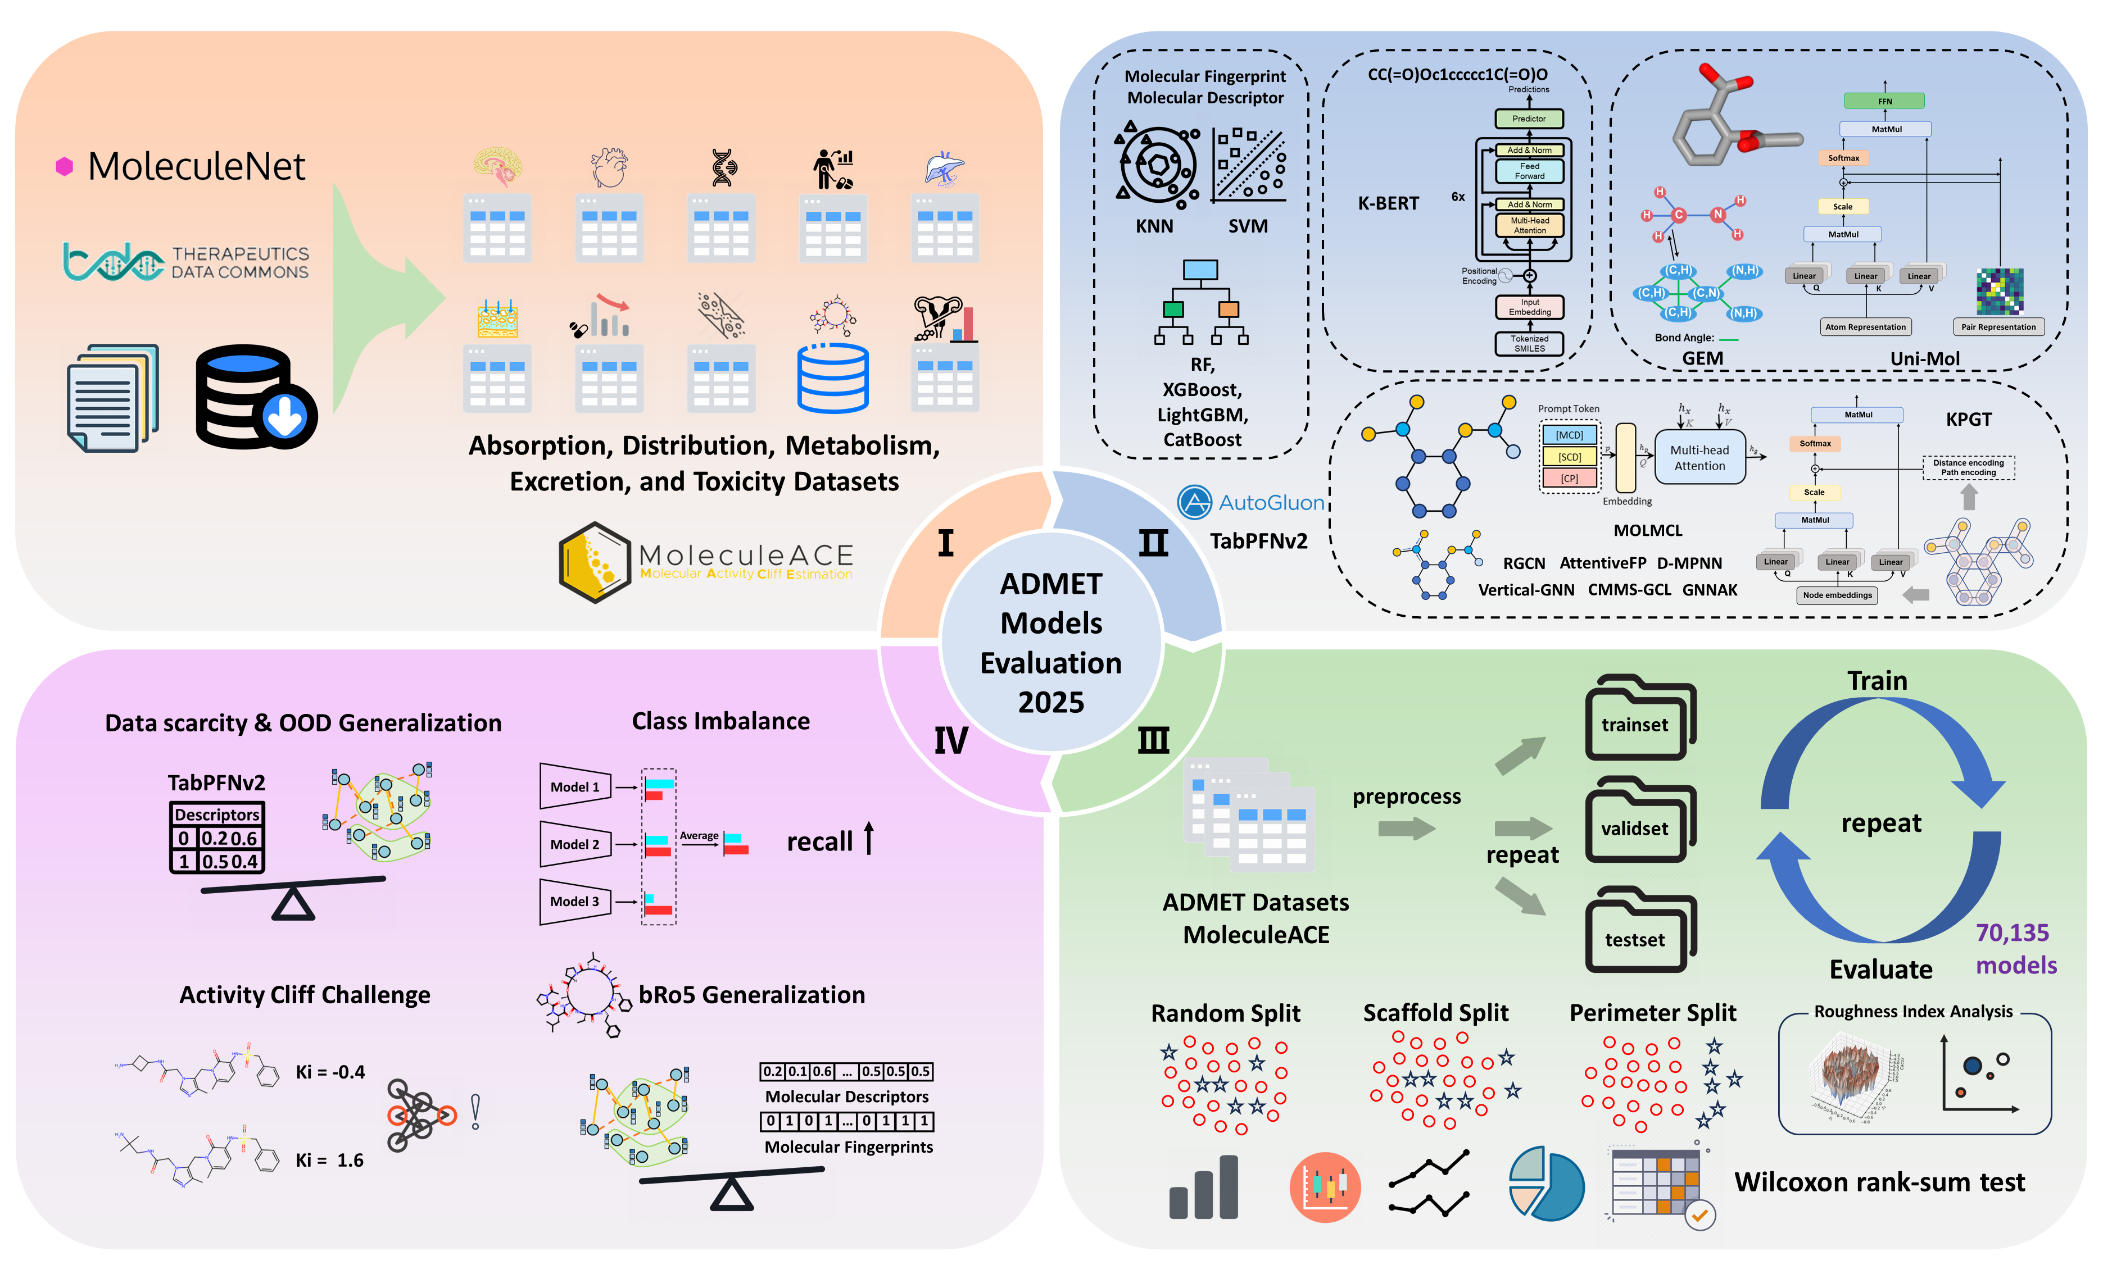
Figure 1 Protocol for the systematic evaluation of ADMET models.

2. Results
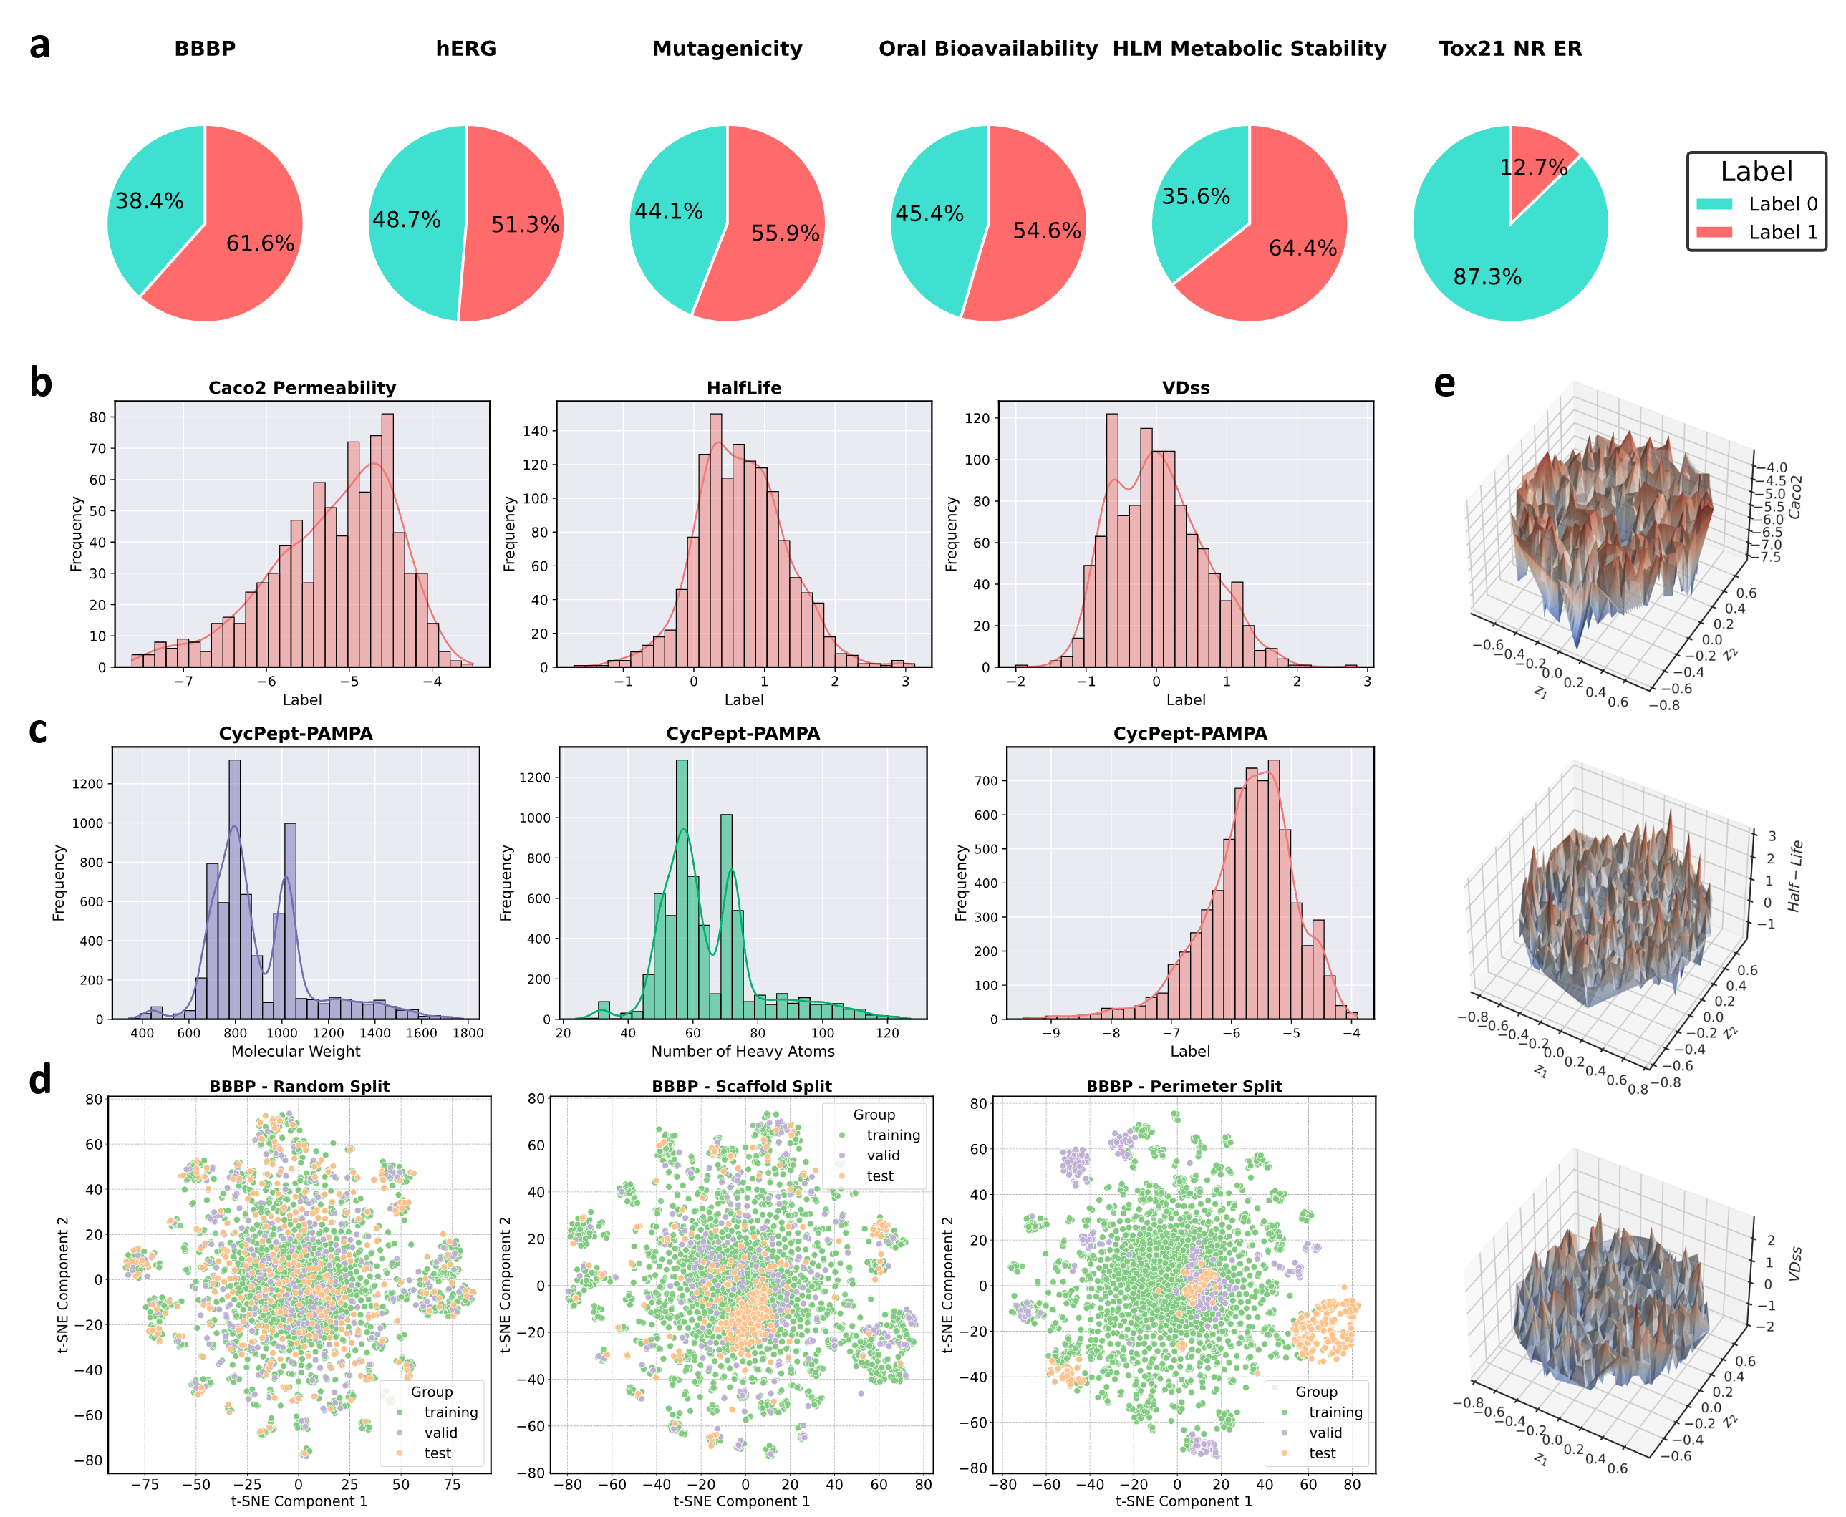
Figure 2 Overview of the druggability datasets. a Ratio of positive to negative samples for six classification datasets. b Label distribution for three regression datasets. c Distribution of molecular features and labels for the cyclic peptide permeability dataset. d Distribution of the training, validation, and test sets for the BBBP dataset under three split strategies (t-SNE projection based on Morgan fingerprints). e 3D molecular property landscape obtained by representing molecules with Morgan fingerprints and compressing the representations into two dimensions via multidimensional scaling; the third dimension represents the molecular property. The property landscape was plotted using code provided by Coley et al.³⁶.
2.1 Overview of this Benchmark Framework
To rigorously assess model performance on tasks relevant to drug development, we curated a benchmark of datasets covering all aspects of ADMET that are both of high interest to the pharmaceutical industry and present significant modeling challenges. These challenges are rooted in the data's intrinsic properties. First, data scarcity is a common hurdle; four of our datasets contain fewer than 2,000 samples, with Caco2 Permeability having fewer than 1,000. Second, class imbalance can severely bias models, a problem exemplified by the Tox21 NR ER dataset with its approximate 1:7 ratio of positive to negative samples (see Figure 2a). Regression tasks may also suffer from a similar challenge as manifested in skewed data distributions shown in Figure 2b. Third, to test generalization to complex molecules, we included a cyclic peptide permeability dataset (CycPept-PAMPA), whose molecules have significantly higher molecular weights and whose labels exhibit a skewed, long-tailed distribution as displayed in Figure 2c. Additional information regarding the dataset statistics can be found in Supplementary Figure 1 and 2.
Our evaluation framework is designed to test models under progressively difficult conditions. We employ three data splitting methods—Random, Scaffold, and Perimeter—to create scenarios with an increasing degree of out-of-distribution (OOD) shift, with the Perimeter Split offering the most stringent test of generalization. Taking the BBBP dataset as an example(for other datasets, see Supplementary Figure 3), Figure 2d illustrates the distribution of its training, validation, and test sets under the three splitting methods. On these datasets, we systematically evaluated a wide range of representative algorithms, from end-to-end deep learning models (e.g., pre-trained GNNs like KPGT) to tabular models that rely on expert-knowledge features (e.g., AutoGluon and TabPFNv2). For detailed information on benchmarked models, see Methods section. To ensure a fair and insightful comparison, we used unified evaluation metrics: the Area Under the Receiver Operating Characteristic curve (AUROC) for classification tasks, as it is threshold-independent. The coefficient of determination (R²) is adopted for regression tasks, as R² more accurately reflects model performance by accounting for both variance explained and prediction bias, whereas Pearson's r can sometimes yield overly optimistic results due to its insensitivity to systematic error³³.
Finally, we analyzed the intrinsic modeling difficulty of the datasets by visualizing their molecular property landscapes. For regression tasks, these 3D landscapes reveal rugged regions where small structural changes lead to dramatic property shifts, indicating the presence of the "activity cliff" phenomenon as shown in Figure 2e. The noticeably rougher landscapes for the HalfLife and VDss datasets suggest they are especially challenging to model, a prediction validated in our subsequent analyses. These carefully selected datasets and evaluation protocols form a comprehensive framework to test modern algorithms against the core challenges of druggability prediction, with the following sections detailing model performance on each specific challenge.

2.2 The Dual Challenge of Small Dataset and Structural Distribution Shift
In druggability prediction tasks, data scarcity and structural distribution shift (out-of-distribution, or OOD) represent two major challenges that frequently impair model generalization. Small training sets lead to overfitting, while significant divergence between training and test molecular structures, as often encountered in real-world drug discovery, can render learned representations less transferable.
To evaluate model robustness under these conditions, we selected eight representative ADMET datasets, four of which (Oral Bioavailability, Caco2 Permeability, HalfLife, and VDss) contain fewer than 2,000 samples. We further applied the Perimeter Split strategy, which constructs stringent OOD scenarios by maximizing structural dissimilarity between the training and test sets (see Figure 2d and Methods). This allows us to concurrently assess both data efficiency and distributional robustness.
We categorized models into two broad classes: (i) end-to-end deep learning models, and (ii) tabular models built on expert-designed features. Among the deep learning architectures, the pretrained graph neural network KPGT consistently delivered the strongest performance across datasets and splits (Figure 3a–f, for statistical tests, see Supplementary Figure 4). Notably, KPGT maintained stable performance even under Perimeter Split, where most models suffered significant degradation. This suggests that well-designed, chemistry-aware pretraining schemes with topological inductive biases can improve generalization in OOD settings. MOLMCL also performed robustly, benefiting from its multi-channel learning and roughness-aware fine-tuning.
In contrast, conventional graph neural networks such as RGCN and AttentiveFP exhibited sharp performance declines under OOD conditions, especially in the low-data setting. This reflects the limitations of shallow message-passing architectures, which struggle to capture long-range dependencies or fail to generalize to unseen scaffolds without explicit pretraining.
Interestingly, integrating domain knowledge can enhance performance even in deep models. For example, Chemprop-RDKit, which augments D-MPNN with 2D molecular descriptors, achieved strong results on tasks like Oral Bioavailability and Caco2 Permeability(Supplementary Figure 5). Certain RDKit descriptors (e.g., TPSA, logP) are highly correlated with key endpoints (Supplementary Figure 6), suggesting that inductive priors derived from human intuition remain valuable in data-limited settings.

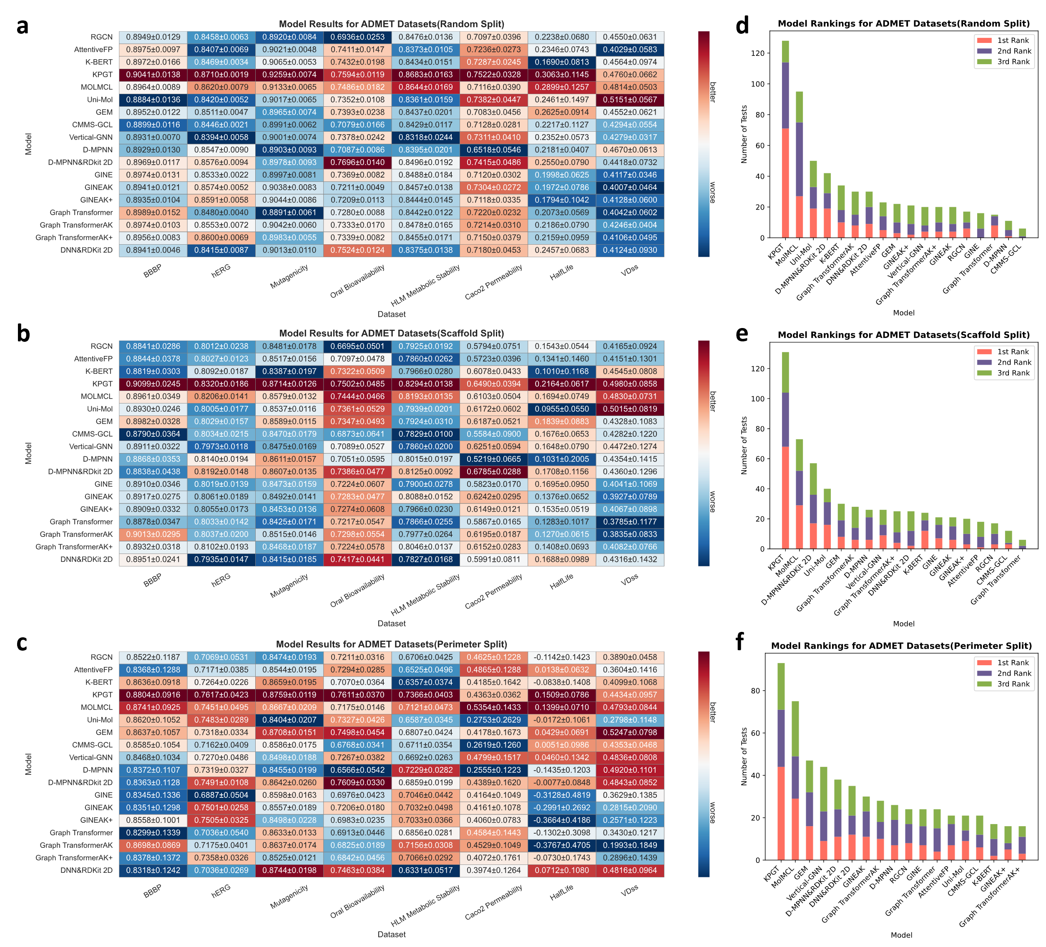
Figure 3. Performance comparison of deep learning algorithms. a-c Heatmaps of cross-dataset performance (Metrics: ROC AUC for classification; R² for regression). Color intensity indicates performance (red is better, blue is worse), with values shown as mean ± standard deviation. d-f Frequency statistics of algorithms entering the Top3 rankings in all experiments.

We also assessed the performance of classical models using different molecular representations. As shown in Figure 4a, the best classical machine learning algorithm was CatBoost, and the best-performing representation was Mordred (see Supplementary Figures 7 and 8 for detailed results). When we incorporated representations learned by pretrained models (e.g., KPGT) into XGBoost predictors, these did not surpass Mordred or RDKit-based representations (Figure 4c), reaffirming the strength of hand-crafted features in low-data regimes.

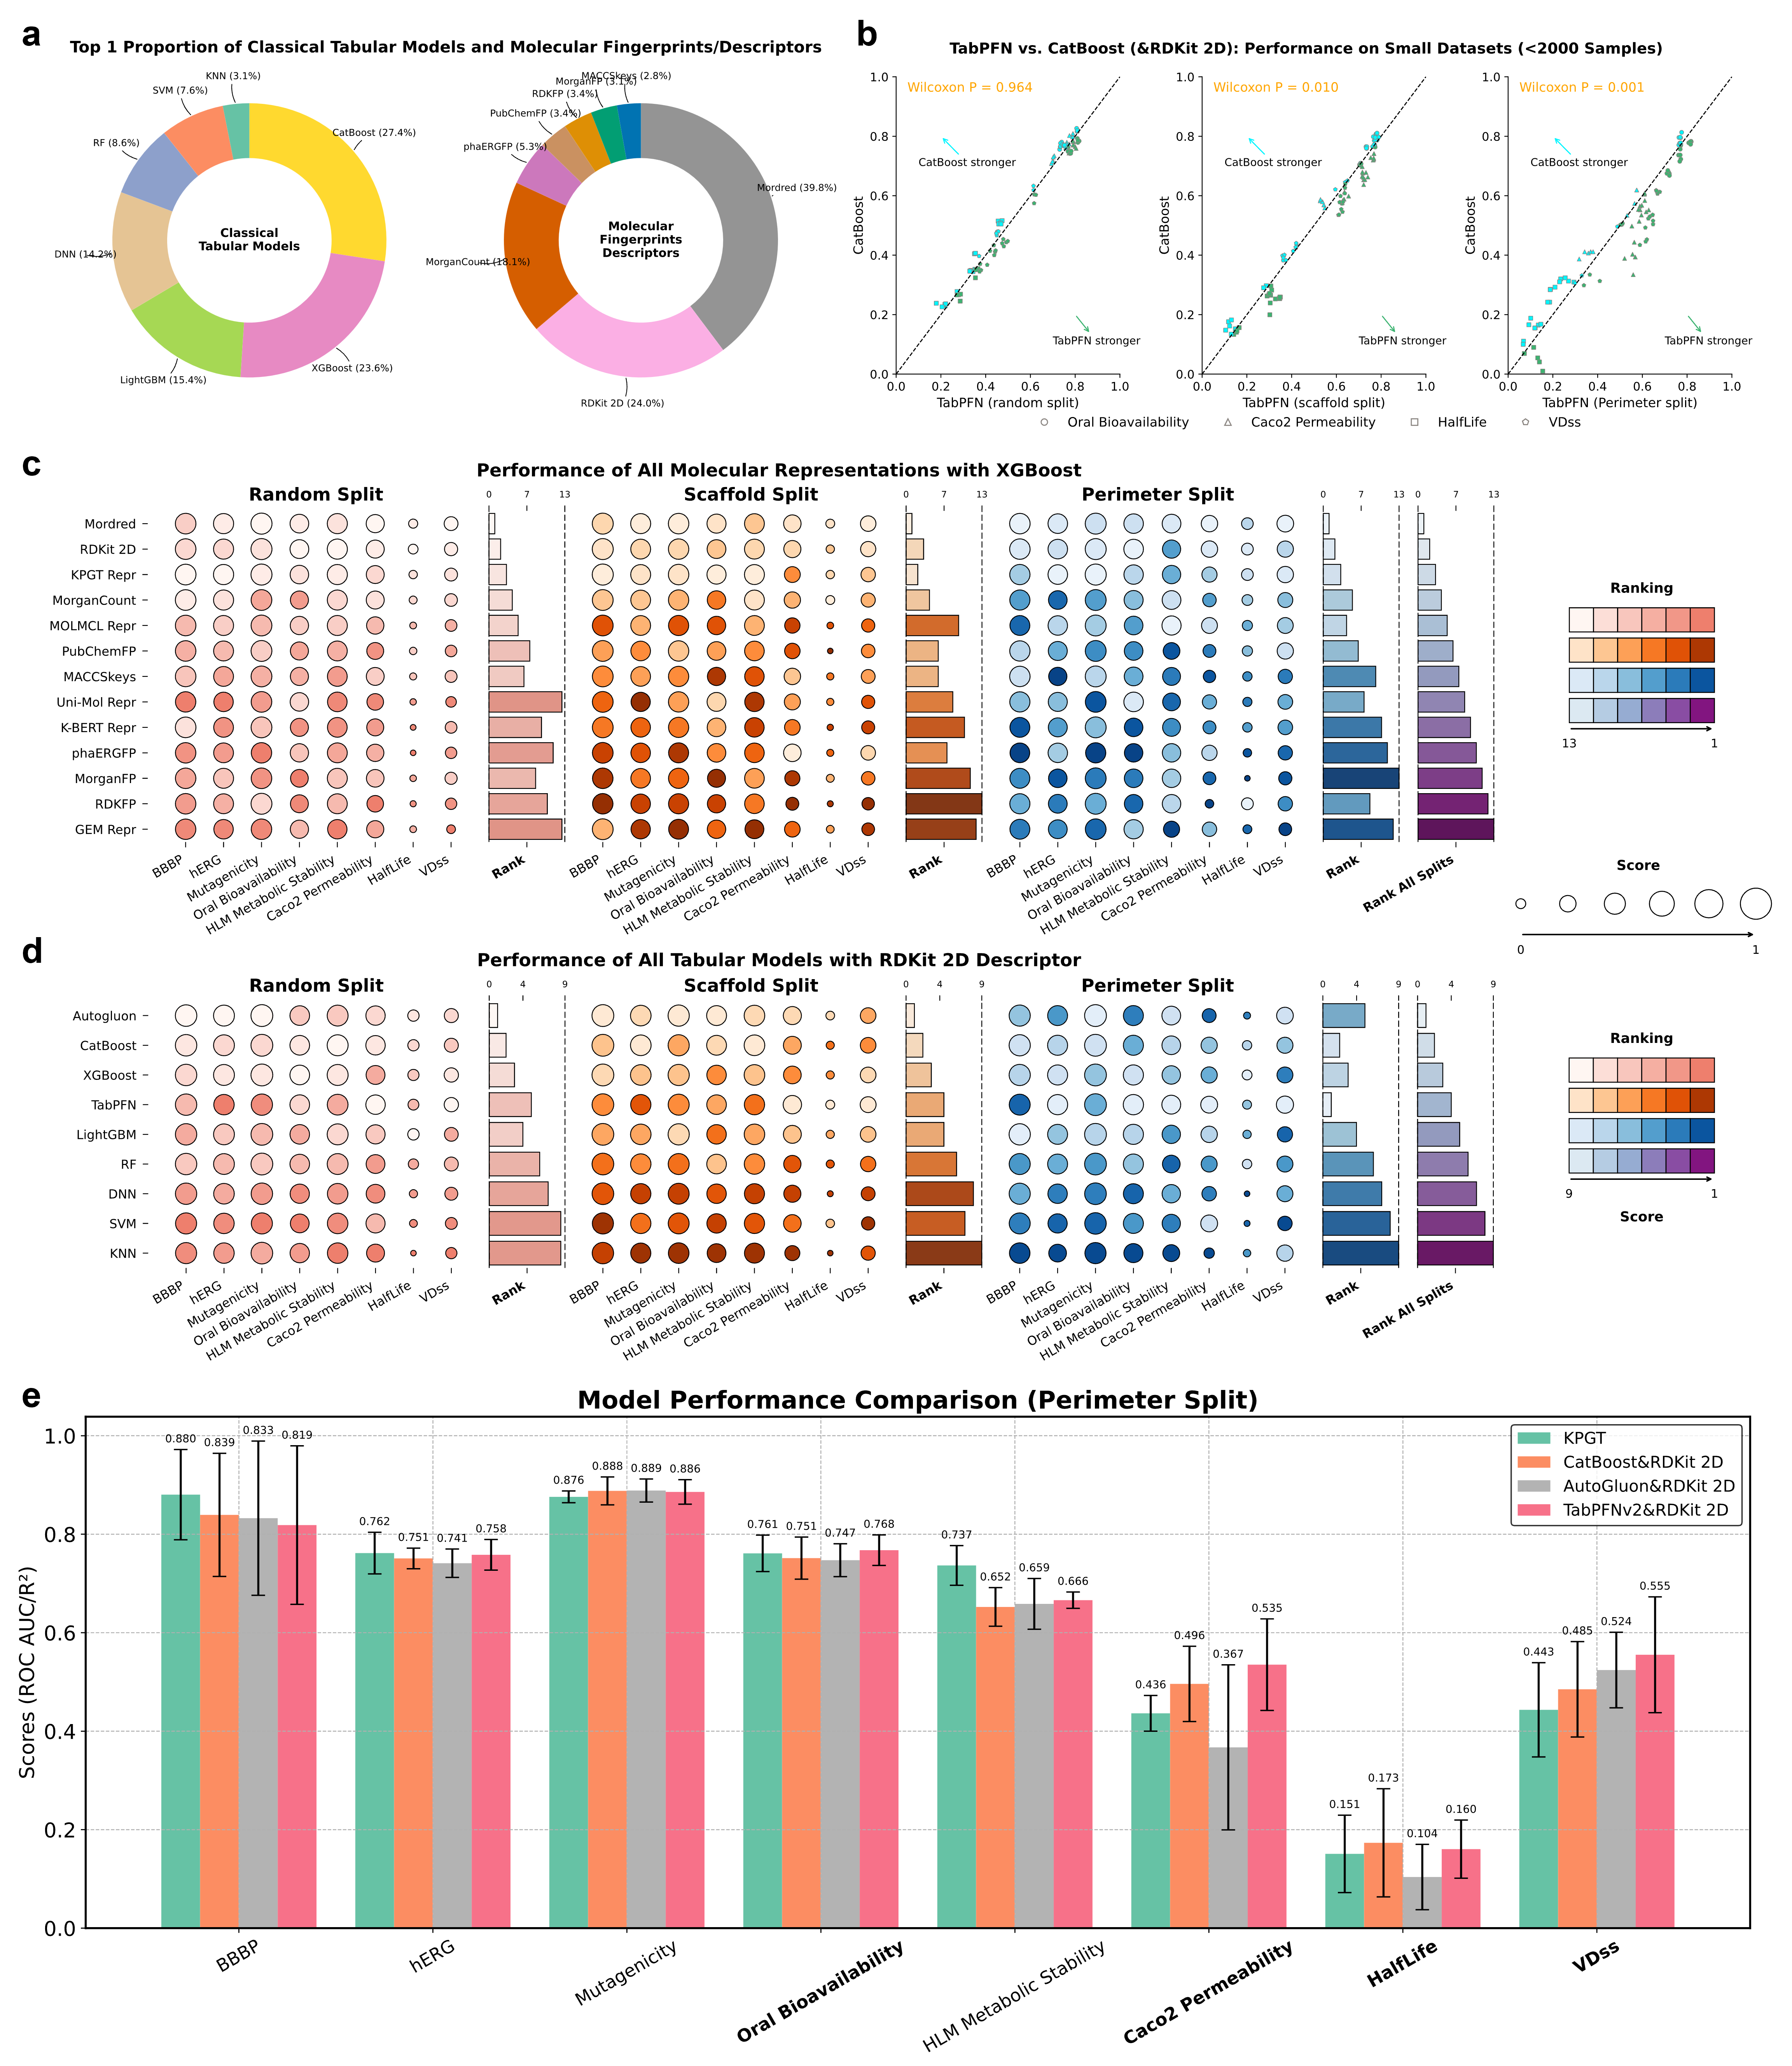
Figure 4. Performance of molecular representations and tabular models. a Proportion of top-1 ranks for traditional methods (classical machine learning algorithms based on fingerprints/descriptors). b Performance comparison of TabPFNv2 and CatBoost (both using RDKit 2D molecular descriptors for representation) on the four small-scale datasets. c Performance comparison of all molecular representations on the eight datasets. d Performance comparison of all tabular prediction models on the eight datasets. e Performance comparison of KPGT, CatBoost, AutoGluon, and TabPFNv2 on Perimeter Split(for results on Random and Scaffold splits, see Supplementary Figure 9). Datasets shown in bold are the four with sample sizes < 2000.

Tabular models using expert features exhibited particularly strong performance. TabPFNv2 consistently outperformed other tabular and deep models across small datasets and the Perimeter Split (Figure 4b, 4d, 4e), indicating that pretraining on synthetic tabular data can yield robust generalization even when no domain-specific pretraining is used. AutoGluon also performed well on random and scaffold splits, but its performance dropped on the Perimeter Split—likely due to overfitting in its ensemble strategy.
To further evaluate the complementarity between modeling paradigms, we ensembled the predictions from KPGT and TabPFNv2 (or CatBoost) using simple averaging. Across multiple datasets, this hybrid ensemble consistently outperformed any single model (Supplementary Figures 10–12), suggesting that deep-learned and handcrafted representations capture complementary structure–activity relationships and can help mitigate each other’s biases.
In summary, our results emphasize that model choice should be context-specific. TabPFNv2 is especially well-suited for low-data and OOD scenarios, while pretrained GNNs like KPGT perform well in richer or more structurally complex regimes. Moreover, ensembling models with orthogonal inductive biases provides a practical and effective means to improve performance under challenging conditions.
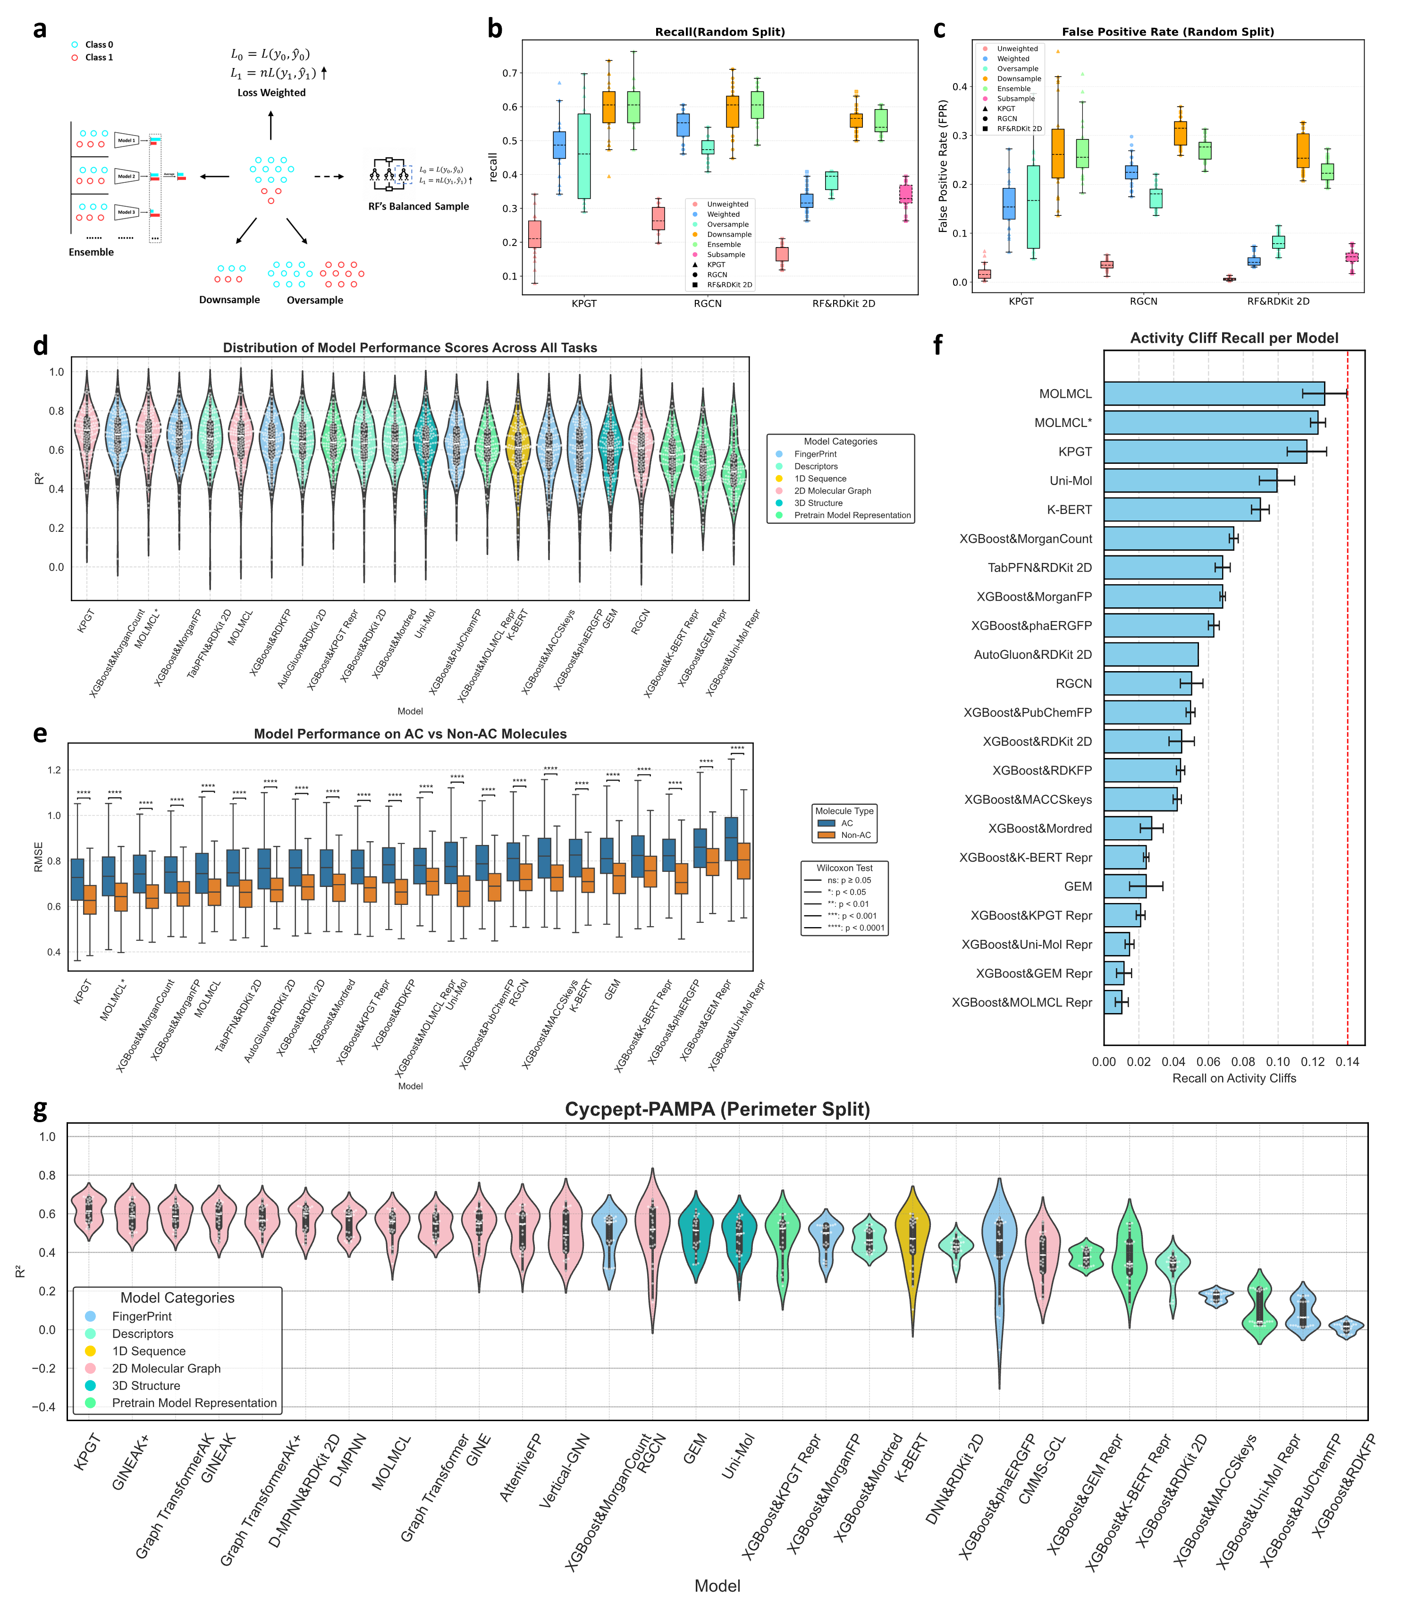
Figure 5 Summary of results for the data imbalance challenge(a-c), the activity cliff challenge(d-f) and the structural generalization challenge (g). a Common strategies for handling imbalanced datasets. b, c Recall and false positive rates of the three models when applying different strategies to the imbalanced dataset. d Overall performance of representative algorithms on 30 MoleculeACE datasets(sorted by mean in descending order, the same applies hereafter, except for Figure 5e). e Performance of representative algorithms on activity cliff (AC) and non-activity cliff (non-AC) molecules in the test set(sorted by mean RMSE on AC in ascending order). f Recall rate of representative algorithms for activity cliff pairs in the test set. g Performance of various models on cyclic peptide. permeability prediction.

2.3 The Challenge of Class Imbalance
Beyond data scarcity and OOD challenge, class imbalance is a formidable and prevalent issue in druggability modeling. To investigate this, we used the Tox21 estrogen receptor (ER) dataset as a case study, where a positive-to-negative sample ratio of approximately 1:7 severely impairs the model's ability to learn the minority class. While many studies have proposed complex algorithmic solutionss^{37,38}, we hypothesized that classic data sampling methods remain highly effective. We systematically evaluated four strategies—class weight adjustment, oversampling, undersampling, and undersampling-based ensembling—on three distinct models: a pre-trained GNN (KPGT), a conventional GNN (RGCN), and Random Forest (RF). RF was selected for its strong baseline performance (Supplementary Figure 8) and a unique, built-in balanced_subsample mechanism that provided an additional point of comparison. See Figure 5a for the methods tested.
Our results confirm that for label imbalance, an ensemble of undersampled models is a reliably effective solution. For KPGT, this strategy dramatically improved the recall rate for the minority class from 0.2174 to 0.6026, while keeping the false positive rate at a moderate level (Figure 5b, c). In contrast, simple class weight adjustment only yielded a minor improvement in recall, while oversampling proved to be volatile and unstable in some experiments. The built-in balanced_subsample strategy unique to Random Forest performed similarly to directly adjusting loss weights. Other evaluation indicators are shown in Supplementary Figure 13.
This finding provides a simple, effective, and highly practical solution for the class imbalance problem: combining classic data processing strategies with modern deep learning models effectively balances performance and stability while improving detection of the minority class.

2.4 The Challenge of Activity Cliffs
A significant challenge in drug discovery is the "activity cliff" phenomenon, where minor molecular modifications lead to dramatic changes in biological activity. These highly non-linear relationships are inherently difficult for models to learn, especially from limited data. To assess model performance against this challenge, we used the MoleculeACE benchmark which is specifically designed to highlight activity cliffs. In terms of overall performance across the 30 MoleculeACE datasets, the pre-trained model KPGT achieved the best results as shown in Figure 5d. We also observed that integrating expert-knowledge features, such as combining the learned representations of MOLMCL with molecular descriptors, consistently improved predictive performance, underscoring the value of supplementing data-driven models with domain knowledge.
In molecular property prediction, the general assumption that structurally similar molecules exhibit similar properties often holds. However, a well-known exception is the phenomenon of “activity cliffs”, in which minor structural modifications lead to large, often unpredictable, changes in biological activity. These cliffs pose a significant challenge for modeling, especially under data-scarce conditions where few examples exist to learn such discontinuities.
To evaluate model performance in this regime, we adopted the MoleculeACE²⁷ benchmark constructed by van Tilborg et al., which is designed to stress-test models on activity cliff (AC) detection. Importantly, the datasets used are all relatively small in size (<4,000 samples), allowing us to concurrently examine robustness under low-data conditions. We selected representative deep learning models covering 1D, 2D, and 3D molecular representations, and evaluated both end-to-end predictors and tabular models using expert features or pretrained embeddings with XGBoost.
As shown in Figure 5d, KPGT achieved the highest average performance across the benchmark, followed by MOLMCL and D-MPNN. Integrating expert-curated features, such as RDKit 2D descriptors and Morgan fingerprints, generally improved performance for several models. For instance, MOLMCL showed notable gains when its learned embeddings were concatenated with RDKit features, supporting the broader theme that hybridization of deep representations with chemistry-based features enhances model robustness.
Despite these improvements, performance on AC molecules remained consistently worse than on non-AC molecules. We analyzed prediction errors across 30 datasets and found that the RMSE on AC samples was significantly higher than on non-AC ones (Figure 5e), confirming that these cliff regions are particularly hard to model. To further challenge the models, we constructed a strict evaluation subset of 314 molecular pairs defined by: (i) high structural similarity (Tanimoto similarity ≥ 0.7), and (ii) ≥100-fold activity difference. A prediction was considered successful if it captured at least a two-log-unit difference in predicted activity. As shown in Figure 5f, the recall rate on these hard cliff pairs was universally low, with no model exceeding a recall of 0.14.
Notably, even 3D-aware models like Uni-Mol and GEM performed poorly in this regime. This is likely because these models operate on a single, RDKit-optimized conformation, which may differ substantially from the bioactive conformer in real biological environments. For flexible or conformationally heterogeneous molecules, such as those with rotatable bonds or macrocyclic scaffolds, this mismatch can introduce substantial predictive error. We tested a multi-conformer extension of Uni-Mol (see Supplementary Figure 14), which provided only marginal performance improvement (R² increase of ~0.02) and still lagged behind top 2D models like KPGT and MOLMCL.
Among all tested models, MOLMCL exhibited relatively better performance on AC tasks, which may be attributed to its scaffold-aware contrastive pretraining strategy and its fine-tuning mechanism guided by the molecular property landscape roughness index. These design features likely enhance its ability to focus on subtle scaffold-level perturbations and discontinuous structure–activity patterns.
These results highlight a critical limitation in current molecular modeling approaches: the inability to learn sharp local discontinuities in structure–activity space. Even models equipped with 3D information or pretraining do not inherently generalize to cliffs. This suggests that progress on AC modeling may require architectural or algorithmic innovations, such as: (i) loss functions tailored to penalize local inconsistency in similar structures, (ii) contrastive learning frameworks that emphasize near-cliff molecular pairs, or (iii) explicit incorporation of property landscape roughness as a constraint during training. While roughness is further explored in Section 2.6, these findings motivate the need for new “activity-cliff-aware” paradigms that move beyond smooth inductive biases.

2.5 The Challenge of Structural Generalization across the bRo5 Chemical Space
Modern drug discovery is increasingly venturing into the "beyond Rule of Five" (bRo5) chemical space, populated by molecules with higher molecular weight, complexity, and conformational flexibility that challenge traditional modeling approaches. Using the prediction of cyclic peptide permeability as our test case, we evaluated model performance in this complex domain, focusing on the most challenging Perimeter Split setting. Our results show that the pre-trained graph neural network, KPGT, significantly outperformed other deep learning models as clearly shown in Figure 5g (results for Random and Scaffold splits are shown in Supplementary Figure 15). This success can be attributed to its global aggregation architecture, which is well-suited for complex topologies, and the robust domain knowledge acquired during pre-training. In general, models based on 2D molecular graphs (e.g., D-MPNN, RGCN) proved more effective than both 1D sequence-based models, which inadequately capture cyclic structures, and 3D conformation-based models.
The underperformance of 3D-aware models like Uni-Mol and GEM highlights a critical bottleneck in current methods. We found that their reliance on a single, calculated 3D conformation is insufficient for highly flexible molecules like cyclic peptides, which exist as a dynamic ensemble of structures³⁹. Even when providing multiple conformations to Uni-Mol, we observed only a marginal performance gain (Supplementary Figure 14) that did not surpass the top 2D graph models. Similarly, classical machine learning models that rely on expert-designed features also struggled in this bRo5 task, likely because existing molecular descriptors were primarily developed and tested on smaller organic molecules. This underscores a key advantage of deep learning: the ability to bypass feature engineering and learn adaptive representations directly from molecular structure, enabling better generalization to novel chemical spaces.
To contextualize KPGT's performance, we compared it against two models specifically designed for cyclic peptides: CycPeptMP and Multi_CycGT. While a CycPeptMP (with a multi-level representation strategy) showed slightly better performance, KPGT generally outperformed Multi_CycGT as shown in Supplementary Figure 16. The strong performance of the large-scale pre-trained model like KPGT is highly encouraging, as it suggests that developing a unified molecular property prediction framework valid across a broad chemical space is feasible. However, this task also reveals that architectural choices are critical; modeling structurally complex molecules necessitates a sufficient number of message-passing layers in GNNs to capture long-range dependencies (see Supplementary Figure 17), pointing to a need for more advanced architectures that can go deeper without performance degradation⁴⁰ due to the challenges of over-smoothing and over-squashing.

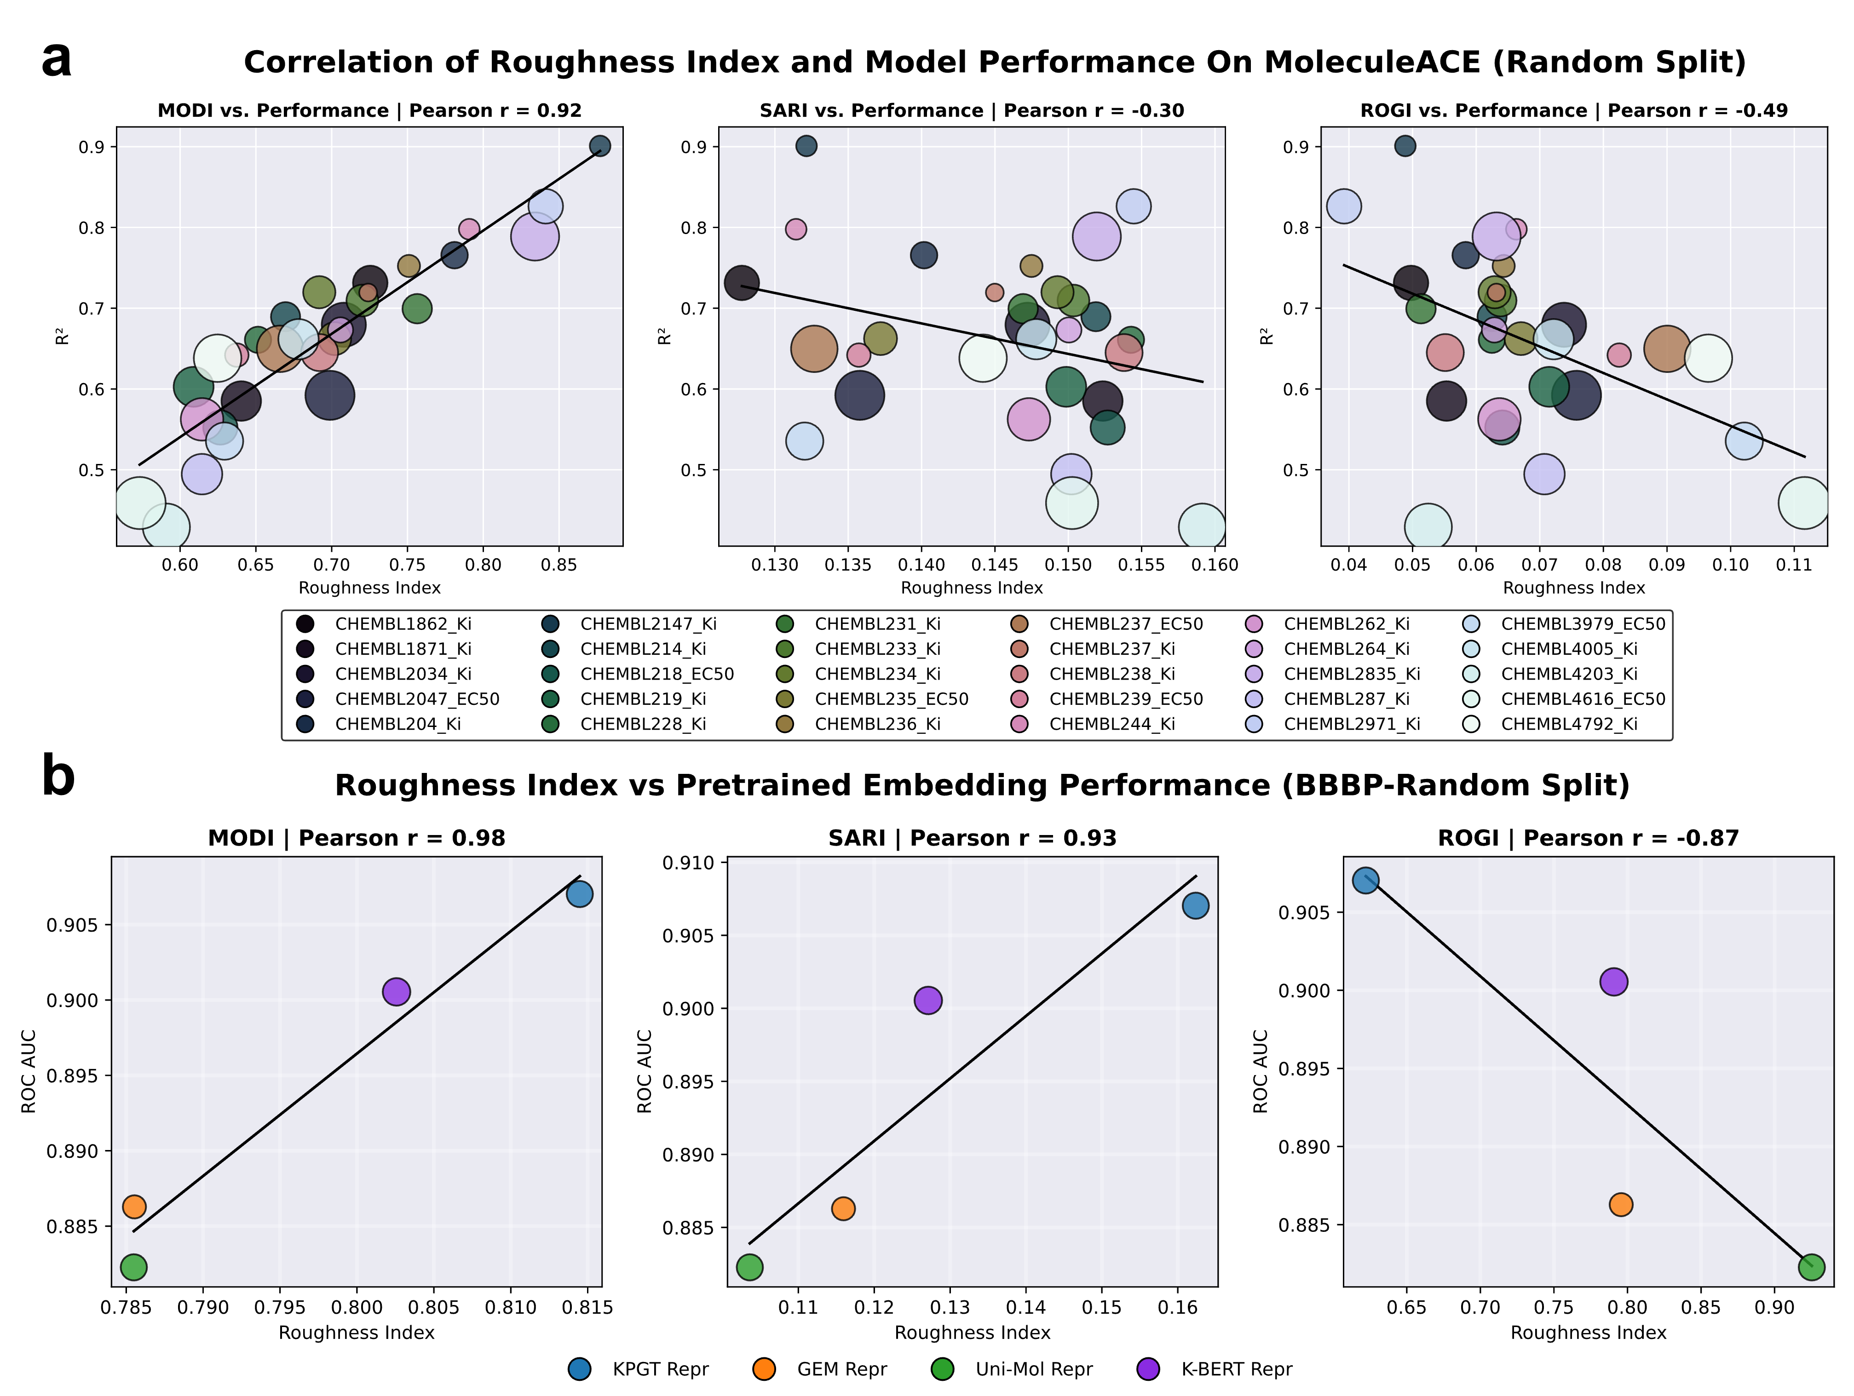
Figure 6 Analysis of molecular property landscape roughness indices. a Correlation between model performance (based on Morgan fingerprints) and the corresponding landscape roughness on the MoleculeACE series of datasets. b Correlation between model performance (based on pre-trained representations) and the corresponding landscape roughness on the BBBP dataset. Note: In all experiments, we only use model performance obtained under the Random Split for analysis, as the roughness index analyzes the entire chemical space, making it difficult to predict performance degradation caused by internal distribution differences between the training, validation, and test sets¹⁸.

2.6 Roughness Index of Property Landscape: Evaluating the Representation Quality of Pre-trained Models
As large-scale pre-trained models become central to molecular machine learning, assessing the quality of their learned representations—beyond downstream task performance—has become increasingly important. Existing evaluation practices typically rely on full training-testing pipelines, which are computationally intensive and often entangle model quality with hyperparameter and dataset effects. To address this, we investigate molecular property landscape roughness indices (see Supplementary Information 1.5) as a lightweight and theoretically motivated alternative for evaluating both dataset modeling difficulty and representation quality.
We examine three widely used roughness indices—MODI, ROGI, and SARI—defined based on structural similarity and property discontinuities (see Methods). A key prerequisite is whether these indices can serve as reliable proxies for dataset difficulty. Using Morgan fingerprints to represent molecules, we compute roughness values for 30 datasets and correlate them with model performance using gradient-boosted decision trees. Among the three indices, MODI shows the strongest correlation with downstream predictive performance (Pearson r = 0.92 on MoleculeACE), whereas SARI and ROGI exhibit weaker or inconsistent trends (Figure 6a, Supplementary Figure 18). This finding suggests that MODI, which quantifies the variance of activity among structurally similar molecules, is especially sensitive to modeling difficulty under real-world structural constraints.
We then turn to evaluating the intrinsic quality of molecular representations produced by pre-trained models. Using embedding (as feature vectors) extracted from KPGT, K-BERT, GEM, and Uni-Mol, we compute the roughness indices on several datasets and assess their relationship with downstream predictive accuracy (using XGBoost as a unified predictor). Across all three indices, smoother property landscapes—i.e., lower ROGI or higher MODI/SARI scores—consistently correlate with better model performance (Figure 6b). KPGT’s embedding, for instance, produces the smoothest property landscape and yields the strongest predictive performance, reinforcing its superiority in learned representation quality. Importantly, these trends hold across different datasets and roughness definitions, validating the robustness of the approach. See Supplementary Figure 19 for detail.
These results highlight two key utilities of roughness indices: (i) MODI can serve as a principled estimator of dataset complexity before model training; and (ii) roughness computed from learned embeddings offers a computationally efficient, architecture-agnostic diagnostic for assessing representation quality. This approach enables early-stage screening of pre-trained models and could guide architecture selection, model pruning, or adaptive fine-tuning in future workflows.
Overall, roughness-based analysis offers a conceptually grounded framework to evaluate and interpret molecular machine learning systems, complementing empirical benchmarking with task-independent diagnostics.

- Discussion
This study presents a systematic and one of the most comprehensive benchmarks of ADMET prediction models under conditions that reflect core scientific challenges: limited data availability, structural distribution shifts, activity cliffs, and extrapolation to the beyond-Rule-of-Five (bRo5) chemical space. Through the training and evaluation of over 70,000 models, we derived several insights with implications for the development and evaluation of molecular machine learning algorithms.
First, we find that tabular foundation models, particularly TabPFNv2, offer unexpectedly strong performance in low-data regimes. Their reliance on expert-designed molecular descriptors provides a form of inductive bias that deep models often lack when data is scarce. In contrast, pretrained graph neural networks (e.g., KPGT) demonstrate robust generalization in complex chemical spaces such as bRo5, where traditional features may inadequately represent molecular flexibility and topology. These findings suggest that model suitability is task-dependent, with distinct architectures favored under different data and chemical constraints.
Importantly, simple ensembling of tabular and deep models consistently yields performance improvements, implying that their respective representations encode complementary information. This points to future opportunities for hybrid architectures or ensemble-aware training objectives that explicitly exploit representational diversity to enhance robustness and generalization.
Despite these advances, our benchmark highlights fundamental limitations. All tested models, including those incorporating 3D conformational information, perform poorly in capturing activity cliffs. This suggests that current architectures may insufficiently model fine-grained structural perturbations or fail to integrate uncertainty at key decision boundaries. New strategies—such as contrastive pretraining focused on scaffold-level perturbations, or loss functions sensitive to local roughness—may be required to systematically improve performance in these regions.
Finally, we show that the molecular property landscape roughness index, particularly MODI, serves as a reliable proxy for both dataset modeling difficulty and representation quality. This provides a theoretically motivated and computationally efficient tool for evaluating pre-trained molecular encoders prior to downstream task training. We anticipate broader applications of this diagnostic framework in guiding pre-trained model selection, architecture search, or dataset curation.
Together, these findings motivate the design of next-generation molecular models that are more adaptive to data regime, aware of structural discontinuities, and interpretable through principled diagnostics. Addressing these challenges will be critical for improving the reliability and applicability of machine learning in drug discovery and beyond.

4. Methods
4.1 Data collection and preparation
We collected ADMET property data from MoleculeNet²¹ the Therapeutics Data Commons (TDC)²⁰ and publicly available datasets in the literature to evaluate the algorithms (data sources are detailed in Supplementary Table 1). For a detailed description of these datasets, see Supplementary Information 1.1. We performed rigorous secondary cleaning on the collected data. The specific process is as follows:
1. Standardized SMILES of molecules. We used the RDKit cheminformatics toolkit⁴¹ to standardize the original SMILES of the molecules: (1) removing explicit hydrogen atoms, (2) breaking metal coordination bonds, (3) performing structure normalization, (4) extracting the largest molecular fragment as the core structure, (5) charge neutralization, and (6) generating standardized SMILES using tautomer enumeration tools from RDKit. For CycPept-PAMPA, we did not perform tautomer enumeration because the molecules in the dataset have a large number of heavy atoms, and due to RDKit limitations, the generated set of SMILES was incomplete.
2. Deduplicate the standardized SMILES representations. For duplicate entries, we retained only one entry for classification problems. If two identical molecules had different labels, they were removed. In regression problems, only entries with a relative standard deviation(RSD) < 0.05 were retained, and the average value of these compounds was defined as the new label. The information of organized dataset is shown in Table 1.
Table 1 Summary of datasets used in this study.
Data Name | Data Type | Category | Data Size
BBBP | binary | Absorption | 3,873
hERG | binary | Toxicity | 9,673
Mutagenicity/AMEs Toxicity | binary | Toxicity | 8,779
Oral Bioavailability | binary | Absorption | 1,444
Human Liver Microsome Metabolic Stability | binary | Metabolism | 5,860
Caco2 Permeability | regression | Absorption | 842
Half Life | regression | Excretion | 1,314
VDss | regression | Distribution | 1,092
CycPept-PAMPA | regression | Toxicity | 6,637
Tox21 NR ER | binary | Toxicity | 5,964
As shown in Figure 1, in this study, we adopted three splitting methods (Random Split, Scaffold Split, and Perimeter Split) to divide the datasets. Perimeter Split is a dataset splitting method based on K-Means clustering and maximum distance pair selection. Its core principle is to assign the farthest sample pairs in the dataset to the test set, thereby constructing an extrapolation-oriented data splitting strategy. This method was implemented using a software package provided by Prudencio et al. ²⁵. To reduce the impact of randomness, we used 5 different random seeds to split the dataset and further changed the random seed under each split to repeat the training-evaluation process five times. Each dataset will yield 25 independent experimental results under one splitting method (with the exception of AutoGluon mentioned below, which only yielded 5 independent experimental results under each split because it is difficult to introduce randomness during its training process). Based on a large number of independent experimental results, we conducted a systematic statistical analysis to minimize the influence of accidental factors such as random seeds and single training runs on the conclusions of model performance evaluation.

4.2 Algorithm selection
Numerous deep learning algorithms for druggability prediction have emerged in recent years. We selected the most representative of these for evaluation, including models based on traditional graph neural network variants like RGCN⁴², AttentiveFP⁴³, and D-MPNN(implemented by Chemprop¹⁰); Vertical-GNN⁴⁴, which uses residual connections to link two graph neural networks; the GNNAK⁴⁵ algorithm, which enhances the expressive power of GNNs; pre-trained models based on SMILES sequences such as K-BERT⁴⁶ and CMMS-GCL⁴⁷, which fuses sequence and graph features; KPGT¹⁷, a pre-trained model employing the Line Graph Transformer (LiGhT) architecture; MOLMCL¹⁸, a multi-channel learning framework; and pre-trained models that start from 3D conformations like Uni-Mol¹⁹ and GEM¹⁶. As shown in Table 2, the majority of these algorithms have a GNN-based core architecture, including five that use a pre-training and fine-tuning approach. The forms of molecular representation cover 1D molecular sequences, 2D molecular graphs, and 3D conformations. To validate the effectiveness of the ADMET-AI platform¹¹, we also included its core architecture, Chemprop-RDKit, in our evaluation. Throughout the training and evaluation process, we used the default hyperparameters for these models. Detailed descriptions and specific hyperparameters for each algorithm are provided in Supplementary Information 1.2 and Supplementary Table 2.

Table 2 Summary of deep learning models evaluated in this study.
Model name | Algorithm type | Pretrain | Pretrain datasize | 2D/3D
RGCN | GNN | no | / | 2D
AttentiveFP | GNN | no | / | 2D
K-BERT | Transformer | yes | 1.8 million | 1D
KPGT | Graph Transformer | yes | 2.0 million | 2D
MOLMCL | GNN | yes | 1.8 million | 2D
Uni-Mol | Transformer | yes | 19 million | 2D+3D
GEM | GNN | yes | 20 million | 3D
CMMS-GCL | GNN&RNN | no | / | 1D+2D
Vertical-GNN | GNN | no | / | 2D
D-MPNN | GNN | no | / | 2D
GNNAK | GNN | no | / | 2D
Classical machine learning algorithms are still widely used in druggability prediction models^{8,48}. We selected several representative algorithms for evaluation, including Support Vector Machine (SVM) ⁴⁹, K-Nearest Neighbors (KNN)⁵⁰, Random Forest (RF)⁵¹ and variants of gradient boosting trees (XGBoost⁵²、LightGBM⁵³、CatBoost⁵⁴). In addition, we incorporated AutoGluon²² , an AutoML framework designed for tabular data, as well as TabPFNv2²³ , a transformer-based model specifically developed for tabular prediction tasks. Collectively, we refer to these methods—based on expert knowledge features—as tabular prediction models. Detailed descriptions of these algorithms can be found in Supplementary Information 1.3. During the training and evaluation process, we first used Bayesian optimization⁵⁵ for hyperparameter tuning on these models (implemented via hyperopt 0.2.7), The number of searches was set to 30 and the hyperparameter ranges are detailed in Supplementary Table 3. AutoGluon comes with a built-in hyperparameter optimization mechanism. For TabPFNv2, we performed tuning based on the official search space provided by the authors. However, the hyperparameter optimization process for TabPFNv2 was extremely computationally intensive and did not yield consistent performance improvements(Supplementary Figure 20). Therefore, we ultimately used the model trained with default hyperparameters. The parameter settings of AutoGluon and TabPFNv2 are shown in Supplementary Table 4.
Which expert knowledge feature is more suitable for drug properties prediction is also a question worthy of attention. The molecular fingerprints we evaluated include Morgan fingerprints, MorganCount, MACCSkeys⁵⁶, pharmacophore fingerprints⁵⁷ and PubChemFP⁵⁸. The molecular descriptors include RDKit 2D molecular descriptors⁴¹ and Mordred⁵⁹. Additionally, we leveraged molecular representations in the form of feature vectors learned by five selected pretrained models. Detailed descriptions of these molecular fingerprints and descriptors can be found in Supplementary Information 1.4. In addition, we also characterized the molecules using the selected feature vectors learned from the five pretrained models. Supplementary Table 5 summarizes the specific information regarding the molecular descriptors and fingerprints we implemented.
Unlike simple binary or multi-level fingerprint vectors and the layer-normalized, missing-value-free feature vectors extracted from pretrained models, molecular descriptors consist of continuous features with varying scales, and some descriptors may contain missing values. Therefore, we performed feature engineering preprocessing on the RDKit 2D molecular descriptors and Mordred. Specific measures include: (1) removing features that are entirely zero or have a missing value proportion exceeding 10%; (2) using the K-Nearest Neighbors method to fill in missing values and deleting columns with a standard deviation of 0 after filling; (3) standardizing all features using z-score normalization.

4.3 Definition of Activity Cliffs and Activity Cliff Scaffolds
To further investigate the performance of various models in activity cliff scenarios, we adopted the definitions for activity cliff scaffolds and activity cliff molecules from Deng et al.³³: an activity cliff is defined as a pair of molecules within the same scaffold whose IC50 values differ by at least two orders of magnitude; an activity cliff scaffold is a scaffold containing such a pair, and an activity cliff molecule is a molecule possessing an activity cliff scaffold. Although activity cliff scaffolds constitute only a small fraction of the 30 datasets, the number of activity cliff molecules is still considerable (Supplementary Table 6).

4.4 Molecular Property Landscape Roughness Index
The roughness index is a property of the molecular property landscape used to evaluate its degree of roughness. Common roughness indices include MODI⁶⁰, SARI⁶¹, and ROGI³⁶ (see Supplementary Information 1.5 for a detailed introduction). We established two tasks for these indices: (1) to rank the performance of models on different datasets; and (2) to rank the performance of models that combine the feature vectors of four pre-trained models (KPGT, K-BERT, GEM, and Uni-Mol) with tabular prediction models. For task (1), we used 2024-bit, radius-2 Morgan molecular fingerprints to represent molecules and calculated the similarity matrix using Tanimoto similarity. For task (2), we extracted the feature vectors of the four pre-trained models on different datasets, used these vectors to represent molecules for roughness calculation, and computed the similarity matrix using cosine similarity. Since MODI requires a distance matrix as input, we used (1 - similarity) as the intermolecular distance. It is worth noting that SARI uses a MACCSkeys Tanimoto similarity of 0.6 as the threshold to assess whether a molecular pair is similar. To apply this threshold to other molecular representations, we calculated dynamic thresholds for various representations across different datasets based on the proportion of molecular pairs that had a MACCSkeys Tanimoto similarity of 0.6.

4.5 Evaluation Metrics and Statistical Analysis Methods
The evaluation metrics for classification problems include ROC AUC, PR AUC, and accuracy, while those for regression problems consist of R², RMSE, and MAE. In our analysis of the Tox21 NR ER dataset, we computed ROC AUC, PR AUC, accuracy, precision, recall, F1 score, false positive rate, and the proportion of positive samples in the predictions to provide a comprehensive assessment of the imbalanced dataset. To assess the importance of molecular descriptors, we utilized the Spearman correlation coefficient to evaluate the relationship between significant features and labels. For examining the correlation between roughness and model performance, we employed the Pearson correlation coefficient. To determine whether there are significant performance differences between the two algorithms, we conducted the Wilcoxon rank-sum test (i.e. Mann-Whitney U test), a non-parametric method suitable for analyzing differences between two independent sample distributions, particularly when the data do not meet the normality assumption or when sample sizes are small.

参考文献
1 Feinberg, E. N., Joshi, E., Pande, V. S. & Cheng, A. C. Improvement in ADMET Prediction with Multitask Deep Featurization. J. Med. Chem. 63, 8835-8848, doi:10.1021/acs.jmedchem.9b02187 (2020).
2 Sertkaya, A., Beleche, T., Jessup, A. & Sommers, B. D. Costs of Drug Development and Research and Development Intensity in the US, 2000-2018. JAMA Network Open 7, e2415445-e2415445, doi:10.1001/jamanetworkopen.2024.15445 %J JAMA Network Open (2024).
3 Qureshi, R. et al. AI in drug discovery and its clinical relevance. Heliyon 9, e17575, doi:https://doi.org/10.1016/j.heliyon.2023.e17575 (2023).
4 Sun, D., Gao, W., Hu, H. & Zhou, S. Why 90% of clinical drug development fails and how to improve it? Acta Pharmaceutica Sinica B 12, 3049-3062, doi:https://doi.org/10.1016/j.apsb.2022.02.002 (2022).
5 Van Norman, G. A. Limitations of Animal Studies for Predicting Toxicity in Clinical Trials: Is it Time to Rethink Our Current Approach? JACC: Basic to Translational Science 4, 845-854, doi:https://doi.org/10.1016/j.jacbts.2019.10.008 (2019).
6 Rehman, A. U. et al. Role of Artificial Intelligence in Revolutionizing Drug Discovery. Fundamental Research, doi:https://doi.org/10.1016/j.fmre.2024.04.021 (2024).
7 Blanco-González, A. et al. The Role of AI in Drug Discovery: Challenges, Opportunities, and Strategies. Pharmaceuticals (Basel) 16, doi:10.3390/ph16060891 (2023).
8 Wei, M. et al. HobPre: accurate prediction of human oral bioavailability for small molecules. J. Cheminform. 14, 1, doi:10.1186/s13321-021-00580-6 (2022).
9 Ogura, K., Sato, T., Yuki, H. & Honma, T. Support Vector Machine model for hERG inhibitory activities based on the integrated hERG database using descriptor selection by NSGA-II. Sci. Rep. 9, 12220, doi:10.1038/s41598-019-47536-3 (2019).
10 Heid, E. et al. Chemprop: A Machine Learning Package for Chemical Property Prediction. J. Chem. Inf. Model. 64, 9-17, doi:10.1021/acs.jcim.3c01250 (2024).
11 Swanson, K. et al. ADMET-AI: a machine learning ADMET platform for evaluation of large-scale chemical libraries. Bioinformatics 40, doi:10.1093/bioinformatics/btae416 (2024).
12 Wang, Y., Wang, J., Cao, Z. & Barati Farimani, A. Molecular contrastive learning of representations via graph neural networks. Nature Machine Intelligence 4, 279-287, doi:10.1038/s42256-022-00447-x (2022).
13 Xiang, H. et al. A molecular video-derived foundation model for scientific drug discovery. Nature Communications 15, 9696, doi:10.1038/s41467-024-53742-z (2024).
14 Rong, Y. et al. in Proceedings of the 34th International Conference on Neural Information Processing Systems Article 1053 (Curran Associates Inc., Vancouver, BC, Canada, 2020).
15 Wu, F., Radev, D. & Li, S. Z. Molformer: Motif-based Transformer on 3D Heterogeneous Molecular Graphs. arXiv e-prints, arXiv:2110.01191, doi:10.48550/arXiv.2110.01191 (2021).
16 Fang, X. et al. Geometry-enhanced molecular representation learning for property prediction. Nature Machine Intelligence 4, 127-134, doi:10.1038/s42256-021-00438-4 (2022).
17 Li, H. et al. A knowledge-guided pre-training framework for improving molecular representation learning. Nature Communications 14, 7568, doi:10.1038/s41467-023-43214-1 (2023).
18 Wan, Y., Wu, J., Hou, T., Hsieh, C.-Y. & Jia, X. Multi-channel learning for integrating structural hierarchies into context-dependent molecular representation. Nature Communications 16, 413, doi:10.1038/s41467-024-55082-4 (2025).
19 Zhou, G. et al. in International Conference on Learning Representations.
20 Huang, K. et al. Therapeutics Data Commons: Machine Learning Datasets and Tasks for Drug Discovery and Development. arXiv e-prints, arXiv:2102.09548, doi:10.48550/arXiv.2102.09548 (2021).
21 Wu, Z. et al. MoleculeNet: a benchmark for molecular machine learning. Chem. Sci. 9, 513-530, doi:10.1039/c7sc02664a (2018).
22 Erickson, N. et al. AutoGluon-Tabular: Robust and Accurate AutoML for Structured Data. arXiv e-prints, arXiv:2003.06505, doi:10.48550/arXiv.2003.06505 (2020).
23 Hollmann, N. et al. Accurate predictions on small data with a tabular foundation model. Nature 637, 319-326, doi:10.1038/s41586-024-08328-6 (2025).
24 Bansal, M. A., Sharma, D. R. & Kathuria, D. M. A Systematic Review on Data Scarcity Problem in Deep Learning: Solution and Applications. ACM Comput. Surv. 54, Article 208, doi:10.1145/3502287 (2022).
25 Tossou, P., Wognum, C., Craig, M., Mary, H. & Noutahi, E. Real-World Molecular Out-Of-Distribution: Specification and Investigation. J. Chem. Inf. Model. 64, 697-711, doi:10.1021/acs.jcim.3c01774 (2024).
26 Leevy, J. L., Khoshgoftaar, T. M., Bauder, R. A. & Seliya, N. A survey on addressing high-class imbalance in big data. Journal of Big Data 5, 42, doi:10.1186/s40537-018-0151-6 (2018).
27 van Tilborg, D., Alenicheva, A. & Grisoni, F. Exposing the Limitations of Molecular Machine Learning with Activity Cliffs. J. Chem. Inf. Model. 62, 5938-5951, doi:10.1021/acs.jcim.2c01073 (2022).
28 Zadorozhny, K. et al. Similarity-Quantized Relative Difference Learning for Improved Molecular Activity Prediction. arXiv e-prints, arXiv:2501.09103, doi:10.48550/arXiv.2501.09103 (2025).
29 Caron, G. et al. Steering New Drug Discovery Campaigns: Permeability, Solubility, and Physicochemical Properties in the bRo5 Chemical Space. ACS Med. Chem. Lett. 12, 13-23, doi:10.1021/acsmedchemlett.0c00581 (2021).
30 Doak, B. C. & and Kihlberg, J. Drug discovery beyond the rule of 5 - Opportunities and challenges. Expert Opinion on Drug Discovery 12, 115-119, doi:10.1080/17460441.2017.1264385 (2017).
31 Green, J. et al. Current Methods for Drug Property Prediction in the Real World. arXiv e-prints, arXiv:2309.17161, doi:10.48550/arXiv.2309.17161 (2023).
32 Kamuntavičius, G. et al. Benchmarking ML in ADMET predictions: the practical impact of feature representations in ligand-based models. (2025).
33 Deng, J. et al. A systematic study of key elements underlying molecular property prediction. Nature Communications 14, 6395, doi:10.1038/s41467-023-41948-6 (2023).
34 Niu, Z. et al. PharmaBench: Enhancing ADMET benchmarks with large language models. Scientific Data 11, 985, doi:10.1038/s41597-024-03793-0 (2024).
35 Chen, J. et al. Data Scaling and Generalization Insights for Medicinal Chemistry Deep Learning Models. J. Chem. Inf. Model. 65, 5887-5898, doi:10.1021/acs.jcim.5c00538 (2025).
36 Aldeghi, M. et al. Roughness of Molecular Property Landscapes and Its Impact on Modellability. J. Chem. Inf. Model. 62, 4660-4671, doi:10.1021/acs.jcim.2c00903 (2022).
37 Lin, T. Y., Goyal, P., Girshick, R., He, K. & Dollár, P. in 2017 IEEE International Conference on Computer Vision (ICCV). 2999-3007.
38 Cui, Y., Jia, M., Lin, T. Y., Song, Y. & Belongie, S. in 2019 IEEE/CVF Conference on Computer Vision and Pattern Recognition (CVPR). 9260-9269.
39 Li, J. et al. CycPeptMPDB: A Comprehensive Database of Membrane Permeability of Cyclic Peptides. J. Chem. Inf. Model. 63, 2240-2250, doi:10.1021/acs.jcim.2c01573 (2023).
40 Ren, J.-N. et al. FGTN: Fragment-based graph transformer network for predicting reproductive toxicity. Arch. Toxicol. 98, 4077-4092 (2024).
41 G, L. RDKit: Open-source cheminformatics. doi:https://www.rdkit.org.
42 Schlichtkrull, M. et al. in The Semantic Web. (eds Aldo Gangemi et al.) 593-607 (Springer International Publishing).
43 Xiong, Z. et al. Pushing the Boundaries of Molecular Representation for Drug Discovery with the Graph Attention Mechanism. J. Med. Chem. 63, 8749-8760, doi:10.1021/acs.jmedchem.9b00959 (2020).
44 Ng, S. S. S. & Lu, Y. Evaluating the Use of Graph Neural Networks and Transfer Learning for Oral Bioavailability Prediction. J. Chem. Inf. Model. 63, 5035-5044, doi:10.1021/acs.jcim.3c00554 (2023).
45 Zhao, L., Jin, W., Akoglu, L. & Shah, N. From Stars to Subgraphs: Uplifting Any GNN with Local Structure Awareness. arXiv e-prints, arXiv:2110.03753, doi:10.48550/arXiv.2110.03753 (2021).
46 Wu, Z. et al. Knowledge-based BERT: a method to extract molecular features like computational chemists. Brief. Bioinform. 23, bbac131, doi:10.1093/bib/bbac131 (2022).
47 Du, B.-X., Long, Y., Li, X., Wu, M. & Shi, J.-Y. CMMS-GCL: cross-modality metabolic stability prediction with graph contrastive learning. Bioinformatics 39, doi:10.1093/bioinformatics/btad503 (2023).
48 Fralish, Z., Chen, A., Skaluba, P. & Reker, D. DeepDelta: predicting ADMET improvements of molecular derivatives with deep learning. J. Cheminform. 15, 101, doi:10.1186/s13321-023-00769-x (2023).
49 Cortes, C. & Vapnik, V. Support-vector networks. Machine Learning 20, 273-297, doi:10.1007/BF00994018 (1995).
50 Taunk, K., De, S., Verma, S. & Swetapadma, A. in 2019 International Conference on Intelligent Computing and Control Systems (ICCS). 1255-1260.
51 Breiman, L. Random Forests. Machine Learning 45, 5-32, doi:10.1023/A:1010933404324 (2001).
52 Chen, T. & Guestrin, C. in Proceedings of the 22nd acm sigkdd international conference on knowledge discovery and data mining. 785-794.
53 Ke, G. et al. in Neural Information Processing Systems.
54 Prokhorenkova, L., Gusev, G., Vorobev, A., Dorogush, A. V. & Gulin, A. J. A. i. n. i. p. s. CatBoost: unbiased boosting with categorical features. 31 (2018).
55 Frazier, P. I. A tutorial on Bayesian optimization. arXiv preprint arXiv:1807.02811 (2018).
56 Durant, J. L., Leland, B. A., Henry, D. R. & Nourse, J. G. Reoptimization of MDL Keys for Use in Drug Discovery. J. Chem. Inf. Comput. Sci. 42, 1273-1280, doi:10.1021/ci010132r (2002).
57 Stiefl, N., Watson, I. A., Baumann, K. & Zaliani, A. ErG: 2D Pharmacophore Descriptions for Scaffold Hopping. J. Chem. Inf. Model. 46, 208-220, doi:10.1021/ci050457y (2006).
58 Bolton, E. E., Wang, Y., Thiessen, P. A. & Bryant, S. H. J. A. R. i. C. C. Chapter 12—PubChem: integrated platform of small molecules and niological activities. 4, 217-241 (2008).
59 Moriwaki, H., Tian, Y.-S., Kawashita, N. & Takagi, T. Mordred: a molecular descriptor calculator. J. Cheminform. 10, 4, doi:10.1186/s13321-018-0258-y (2018).
60 Golbraikh, A., Muratov, E., Fourches, D. & Tropsha, A. Data set modelability by QSAR. J. Chem. Inf. Model. 54, 1-4, doi:10.1021/ci400572x (2014).
61 Peltason, L. & Bajorath, J. SAR index: quantifying the nature of structure-activity relationships. J. Med. Chem. 50, 5571-5578, doi:10.1021/jm0705713 (2007).

